Project Design Phase-II
Data Flow Diagram & User Stories
Date | 14 July 2026
Team ID
Project Name | HouseRent India — MERN Property Rental & Sale Platform
Maximum Marks | 4 Marks

Data Flow Diagrams:
A Data Flow Diagram (DFD) is a visual representation of the information flows within HouseRent India. It shows how data enters and leaves the system, what processes act on it, and where it is stored.
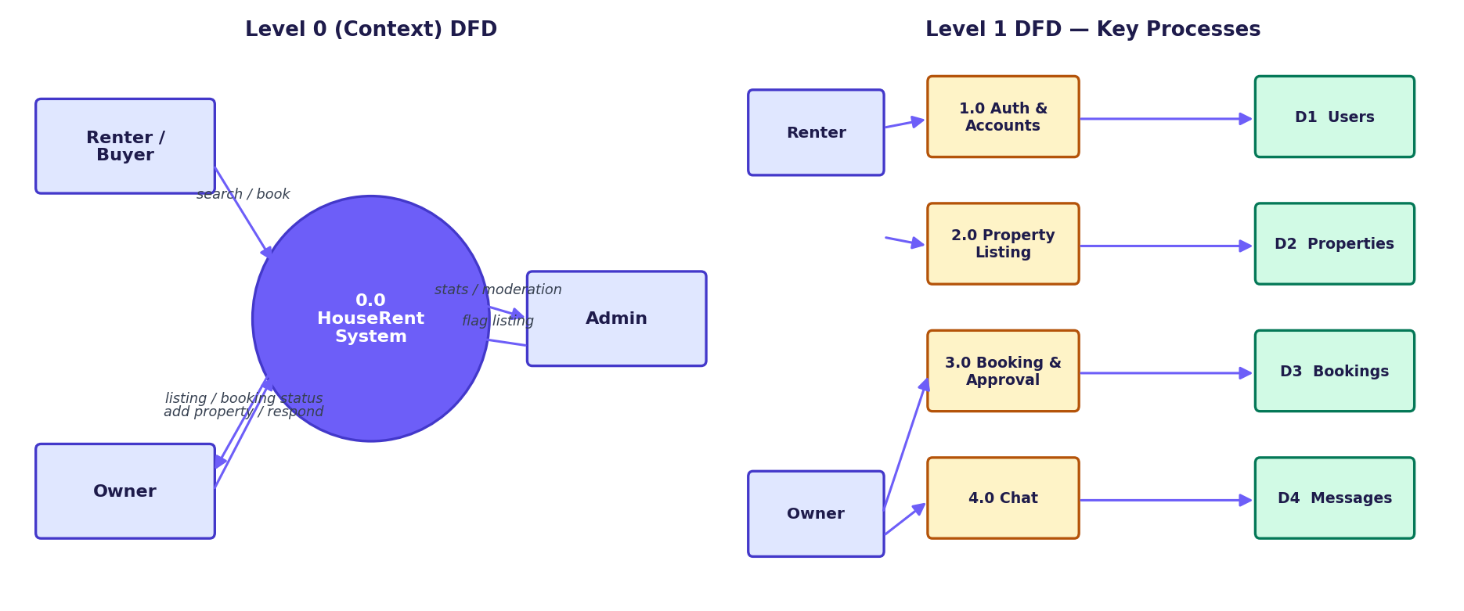
Figure 1: Level 0 (context) and Level 1 data flow diagrams for HouseRent India

User Stories
Use the below template to list all the user stories for the product.
User Type | Functional Requirement (Epic) | User Story Number | User Story / Task | Acceptance Criteria | Priority | Release
Renter/Buyer | Registration | USN-1 | As a user, I can register for the application by entering my name, email, password, phone, and a security question/answer. | I can access my account/dashboard after registering | High | Sprint-1
Renter/Buyer | Login | USN-2 | As a user, I can log into the application by entering email & password. | I land on my role-specific home page | High | Sprint-1
Renter/Buyer | Forgot Password | USN-3 | As a user, I can reset my password by answering my security question without needing email delivery. | I can set a new password and log in with it | Medium | Sprint-1
Renter/Buyer | Property Search | USN-4 | As a renter, I can search and filter properties by city, price range, bedrooms, and type. | Results update live as I type/filter | High | Sprint-1
Renter/Buyer | Booking Request | USN-5 | As a renter, I can send a booking (rent) or purchase (sale) request with a message. | The request appears in "My Bookings" as Pending | High | Sprint-1
Renter/Buyer | Booking Tracking | USN-6 | As a renter, I can view the status of my bookings and cancel a pending one. | Status updates reflect Owner's decision in real time | Medium | Sprint-1
Renter/Buyer | Chat | USN-7 | As a renter, I can chat with the property owner once my booking request is sent. | Messages I send appear instantly; new messages auto-refresh | Medium | Sprint-2
Owner | Registration/Login | USN-8 | As an owner, I can register/login separately from a renter account using the same email. | Both accounts work independently with their own password | High | Sprint-1
Owner | Property Listing | USN-9 | As an owner, I can add a property with photos, price, and details. | The listing appears immediately in search results | High | Sprint-1
Owner | Property Management | USN-10 | As an owner, I can edit or delete my own listings. | Changes reflect immediately for renters browsing | Medium | Sprint-1
Owner | Booking Requests | USN-11 | As an owner, I can view and approve/reject incoming booking requests. | Renter sees the updated status instantly | High | Sprint-1
Owner | Listing Removal Response | USN-12 | As an owner, I can consent to or decline an admin's removal request with a stated reason. | Listing is removed only if I consent | Low | Sprint-2
Administrator | Dashboard | USN-13 | As an admin, I can view platform-wide stats, users, properties, and bookings. | All records load correctly with counts matching the database | Medium | Sprint-2
Administrator | User Management | USN-14 | As an admin, I can activate or deactivate a user account. | Deactivated users can no longer log in | Medium | Sprint-2
Administrator | Listing Moderation | USN-15 | As an admin, I can flag a listing for removal with a reason. | Listing stays live until the owner responds | Low | Sprint-2

